AI-Enabled PMO Hub in Fintech
A Smart Governance Model for Project Prioritization, Risk Prediction, and Delivery Visibility
MBA – AI for Business Case Study Report
Prepared by: Esraa Ashraf
Industry Context: PMO and Fintech Project Governance
Date: April 2026
Presented to: Prof. Ahmed ElSeddawy
Vice Dean – Educational Affairs AASTMT – Smart Village
Ahmed.Bahgat@aast.edu

Executive Summary
This report presents an academic case study on how a fintech organization can transform its Project Management Office through an AI-enabled PMO Hub. The proposed framework responds to a practical problem common in fintech delivery environments: PMO governance is frequently dependent on spreadsheets, manually consolidated status updates, delayed escalation cycles, and descriptive reporting that explains what has already happened rather than what is likely to happen next. In organizations where delivery speed, compliance, channel readiness, and partner integrations directly affect commercial performance, this mode of governance is too slow and too reactive.
The report positions the PMO not as an administrative reporting function but as a strategic control layer that links project execution with business value. The selected case is a medium-to-large fintech organization running a mixed portfolio of revenue-generating integrations, digital initiatives, operational enhancements, compliance changes, and reporting projects. In this environment, weak visibility into delay drivers, readiness risks, dependencies, and resource pressure reduces delivery quality and slows executive decision-making.
The proposed solution is an AI-enabled PMO Hub that integrates project, risk, milestone, resource, and financial data from enterprise systems and workflow tools. The solution combines machine learning, natural language processing, anomaly detection, rule-based governance logic, generative AI summaries, and robotic process automation. Together, these capabilities improve prioritization, forecast delivery risk, enhance go-live readiness visibility, automate repetitive PMO tasks, and provide role-based dashboards for operational teams and executives.
Because real fintech project data is confidential, the analysis uses a synthetic dataset representing fifty projects, one hundred and forty-six risks, three hundred milestones, and three hundred and five resource records. Descriptive, diagnostic, predictive, and prescriptive analytics were applied to demonstrate how data-driven PMO governance can identify high-risk projects earlier, highlight meaningful delivery patterns, and support faster interventions. The analysis shows that projects with high dependency counts, more change requests, larger issue backlogs, and high defect volumes are significantly more likely to experience delays and lower readiness scores. It also shows that AI-supported governance improves the timing and quality of escalation, which in turn supports earlier value realization and better operational control.
Overall, the report concludes that an AI-enabled PMO Hub is both strategically relevant and operationally feasible for fintech organizations. The model supports digital transformation by moving the PMO from fragmented and retrospective reporting toward integrated, predictive, and intelligence-led governance. It also provides a practical way to connect AI adoption with ERP integration, workflow automation, and measurable business value.
1. Introduction
Artificial intelligence has become a major driver of enterprise transformation across industries, especially in sectors that are data-rich, operationally complex, and under continuous pressure to make decisions quickly and accurately (Davenport & Ronanki, 2018; Marr, 2021). In practice, AI is no longer limited to front-end chatbots or isolated analytics models. Organizations increasingly apply AI to forecasting, monitoring, workflow orchestration, risk scoring, process automation, and decision support. This shift is particularly relevant in fintech, where product delivery is fast, integration-heavy, compliance-sensitive, and tightly connected to business growth.
Within fintech organizations, the Project Management Office serves as an essential coordination and governance function. The PMO consolidates delivery status, tracks risks and dependencies, supports stakeholder alignment, monitors milestones, and often plays a central role in production readiness and decision escalation. However, many PMOs still rely on fragmented data sources and manual reporting processes. As a result, governance remains descriptive and retrospective. Leadership sees what has already gone wrong, but it does not always gain early enough insight into what is likely to go wrong next.
This report develops a case study on an AI-enabled PMO Hub designed specifically for a fintech context. The objective is not to replace project managers or governance forums, but to strengthen them through better data integration, predictive analytics, automation, and decision support. The report follows the exact structure expected in the assignment brief and uses a formal academic style similar to applied business papers. It also includes analytical outputs, dashboards, diagrams, and implementation logic so that the report remains academically rigorous while still being practical and business-oriented.
3. Project Scope & Required Components
3.1 Industry & Business Context
Fintech is a broad industry built around the digital delivery of financial products and services, including payments, consumer finance, digital wallets, payout services, acquiring, embedded finance, and financial infrastructure. What distinguishes fintech from many traditional service sectors is the combination of high operational intensity and high strategic urgency. Services must be reliable and scalable, but they also need to be launched, enhanced, and integrated quickly. Product timelines are shaped by customer demand, partner requirements, compliance changes, and competitive pressure.
3.2 Overview of the Selected Industry and Organization Type
The selected industry in this case study is fintech, with emphasis on a delivery environment similar to payment and digital-financial-service organizations. The assumed organization type is a medium-to-large fintech enterprise that manages a diverse portfolio of initiatives. These initiatives include new merchant or partner integrations, digital-channel enhancements, internal process improvements, compliance changes, reporting initiatives, and production-readiness activities.
3.3 Key Business Challenges Faced Before AI Adoption
Before AI adoption, the PMO faces several recurring challenges. First, project information is dispersed across spreadsheets, trackers, workflow tools, emails, and meeting notes. Second, prioritization discussions are often influenced by urgency, stakeholder pressure, or fragmented local visibility rather than an evidence-based portfolio view. Third, risks are escalated after symptoms become visible rather than at the stage when early intervention would be more effective. Fourth, PMO teams spend a large amount of time consolidating reports instead of analysing portfolio signals.
3.4 Market Conditions and Competitive Environment
The competitive environment in fintech is unusually demanding. Firms must innovate rapidly, launch new capabilities faster than traditional players, and maintain service reliability across multiple channels. Competitive pressure does not come only from other fintech firms; it also comes from banks, digital platforms, super apps, and infrastructure providers that increasingly compete for similar customer and partner relationships.
3.5 Problem Statement
This case study addresses the problem of how a fintech PMO can move from reactive and descriptive governance toward predictive, automated, and intelligence-led governance without losing control, explainability, or alignment with enterprise systems.
3.6 Clearly Define the Business Problem
The business problem is that traditional PMO governance in fintech cannot reliably predict delivery delays, prioritize initiatives objectively, or assess go-live readiness early enough to support proactive intervention. Project information exists, but it is scattered, inconsistently structured, and underused. As a result, leadership receives fragmented views, while PMO teams spend excessive effort preparing reports instead of generating actionable insight.
3.7 Explain Why Traditional Systems or Decision-Making Methods Were Insufficient
Traditional PMO methods depend heavily on spreadsheet reporting, static traffic-light status, manual governance packs, and periodic review meetings. These methods are insufficient because they capture current symptoms rather than future likelihoods. They do not make meaningful use of historical patterns, text-based risk notes, or cross-project dependency relationships. Consequently, they provide limited support for early warning and weak support for evidence-based prioritization.
Decision-making under this traditional model is also vulnerable to inconsistency. Projects may be escalated because they are visible rather than because they are objectively most risky. High-value projects may receive delayed attention if their problems are hidden in narrative updates or siloed trackers. Therefore, the limitation of the traditional system is both analytical and managerial: it neither surfaces the right patterns quickly enough nor supports sufficiently consistent intervention.
3.8 Identify Operational, Strategic, or Financial Gaps
Operational gaps include delayed issue visibility, inefficient reporting cycles, limited dependency awareness, and fragmented readiness tracking. Strategic gaps include weak portfolio prioritization, slower executive response, and reduced alignment between delivery activity and business value. Financial gaps include delayed revenue realization from production projects, inefficient use of PMO capacity, avoidable overruns, and rework caused by late governance intervention.
3.9 Data Analytics Component (Mandatory)
The PMO Hub is designed as a data-driven governance framework. Its analytical core depends on the ability to integrate portfolio data from multiple sources, organize it into a usable model, and transform it into descriptive, diagnostic, predictive, and prescriptive insight. The analytics component is therefore mandatory not only to satisfy the assignment brief but also because it is central to the business case itself.
3.10 Students Must Include Data Analytics Concepts, Such As:
The case applies core analytics concepts that are commonly used in business AI initiatives: data structuring, multi-source integration, performance measurement, descriptive summarization, root-cause analysis, predictive scoring, recommendation logic, and dashboard-driven decision support.
3.11 Type of Data Used (Structured, Unstructured, Real-Time, Historical)
The dataset and conceptual system combine several categories of data. Structured data includes planned budget, actual budget, planned duration, actual duration, number of issues, risk counts, dependency counts, UAT completion, and resource utilization. Semi-structured or unstructured data includes status comments, issue descriptions, risk notes, meeting minutes, and governance updates, which can be processed using natural language processing.
Historical data is essential because predictive governance requires prior patterns from completed and ongoing initiatives. Near real-time data is also relevant in a live implementation, especially when issue logs, milestone updates, approvals, or readiness signals change during the week. The PMO Hub therefore treats data variety not as a technical detail but as a core governance requirement.
3.12 Data Sources (ERP Systems, CRM, IoT, Social Media, Transaction Data, etc.)
In this case, relevant data sources include PMO milestone trackers, issue logs, risk registers, project status reports, ERP finance data, resource planning records, vendor-related workflow data, testing and defect data, and meeting notes. While CRM, social media, or IoT streams are less central to the chosen PMO use case, the architecture remains flexible enough to absorb external or operational signals where relevant.
4. AI Solution Overview
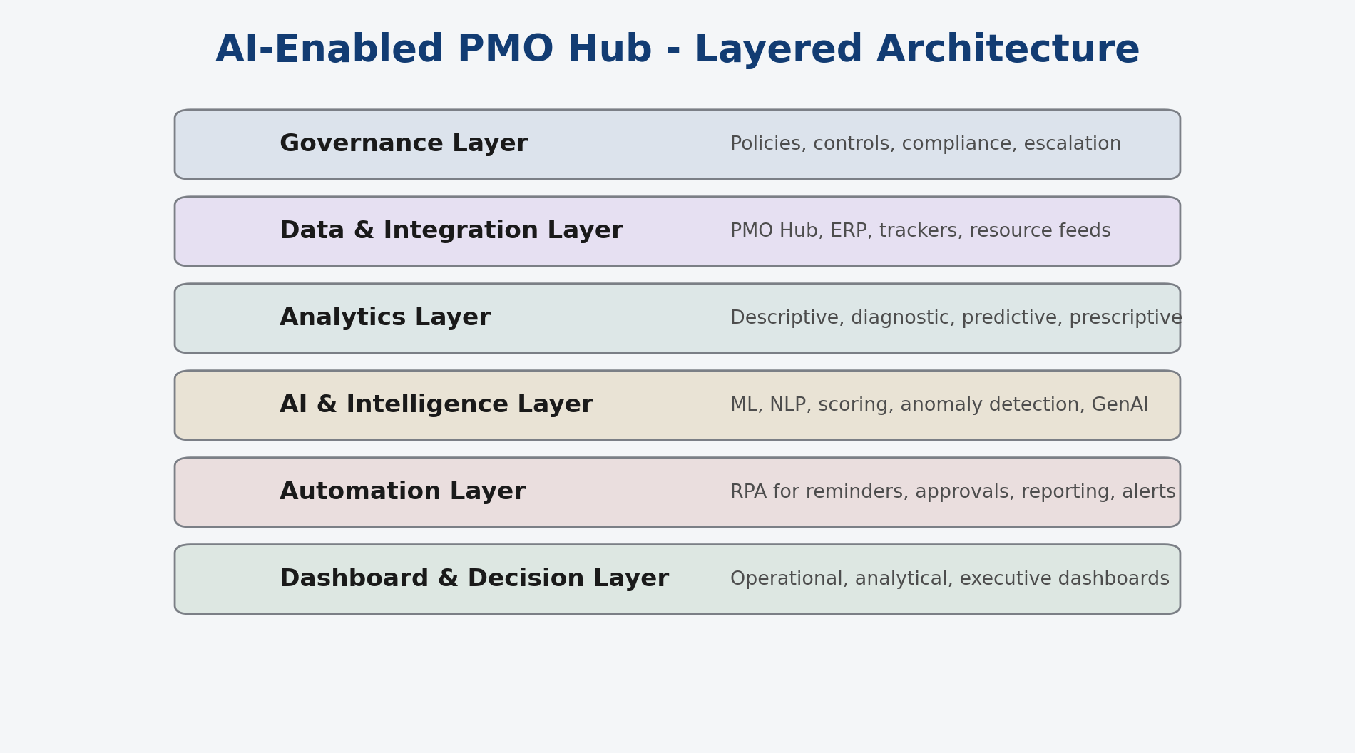
Figure 1. AI-Enabled PMO Hub layered architecture.
4.1 Description of the AI Technology Used
The proposed PMO Hub uses a combination of AI and automation technologies rather than relying on a single machine-learning model. Machine learning supports delay prediction, readiness forecasting, and risk scoring. Natural language processing analyses comments, risk narratives, issue descriptions, and meeting notes to surface themes that would be difficult to capture through structured fields alone. Anomaly detection helps identify abnormal project behaviour such as sudden increases in defects or issue growth. Rule-based governance logic converts organizational policies into explainable controls and escalation conditions. Generative AI can produce concise summaries for governance meetings and executive reporting.
4.2 Business Functions Impacted
The PMO Hub affects multiple business functions. The PMO itself benefits through stronger portfolio visibility, faster reporting, and better decision support. Operations teams benefit from earlier identification of readiness risks and implementation constraints. Finance benefits from better visibility into budget variance and the timing of value realization. Compliance benefits because high-impact projects can be identified and governed more consistently. Technology and testing teams benefit through better visibility into issue concentrations, milestone pressure, and go-live readiness.
4.3 Explanation of How AI Addresses the Defined Problem
AI addresses the defined business problem by changing the timing and quality of governance insight. Instead of waiting for delays to become visible in late-stage status updates, the PMO Hub estimates likely delay, identifies readiness deterioration, and highlights projects that require attention. Instead of relying only on subjective prioritization, it combines strategic value, delivery risk, dependency concentration, compliance impact, and readiness indicators into a more objective scoring model.
4.4 Explain MLM (Supervised, Unsupervised and Semi-Supervised)
Supervised learning is used when historical labels are available. In this case, it can classify whether a project is likely to be delayed or whether a project is likely to be ready for go-live. Models such as logistic regression, decision trees, and random forests are suitable because they provide interpretable outputs and can work with mixed project features.
4.5 Explain RPA in Your Case Study
RPA is a key component of the case because many PMO activities are repetitive, rules-based, and timing-sensitive. Examples include collecting structured updates, sending reminders for late milestones, triggering escalation notifications, consolidating portfolio packs, updating dashboards, and routing approval tasks. In a traditional PMO these tasks consume a large amount of effort and create delays between signal generation and management action.
4.6 Don’t Forget Your Explanation About SDLC Methodology
The recommended implementation approach is a hybrid SDLC aligned with enterprise delivery practice. Planning and requirements analysis are used to define the business case, stakeholder needs, governance use cases, and data requirements. Design covers architecture, dashboards, rule logic, model selection, and integration mapping. Development includes model building, rule configuration, dashboard creation, and workflow automation. Testing includes functional testing, data validation, and user acceptance testing. Deployment begins with a pilot portfolio before broader rollout. Monitoring then evaluates model quality, usage, decision impact, and the need for recalibration.
5. Analytical Techniques (Applied)
5.1 Descriptive Analytics
Descriptive analytics was used to summarize the portfolio baseline. In the synthetic dataset, this involved measuring health distribution, average delay days, readiness scores, open risk counts, issue volumes, and budget variance. Descriptive analysis provides the first level of PMO intelligence because it transforms raw data into a portfolio picture that decision-makers can read quickly.
5.2 Diagnostic Analytics
Diagnostic analytics examines why outcomes are occurring. In this case, the analysis indicated that higher dependency counts, larger issue backlogs, more change requests, and higher defect volumes are associated with worse delay outcomes and lower readiness scores. Projects with low resource utilization or high compliance impact also tended to show weaker performance patterns.
5.3 Predictive Analytics
Predictive analytics was represented through three main outputs: AI-predicted delay days, AI-priority score, and go-live readiness score. These measures provide forward-looking visibility. Instead of saying only that a project is currently amber, the PMO Hub can estimate the likelihood of future deterioration or the likelihood that a project is genuinely ready for deployment.
5.4 Prescriptive Analytics
Prescriptive analytics builds on diagnosis and prediction to recommend action. In the PMO Hub, prescriptive logic identifies which projects should be escalated, which require resource support, which may need sequence adjustment, and which should be held from go-live until readiness improves. It also supports prioritization decisions by combining strategic value with delivery risk and readiness conditions.
5.5 Key Performance Indicators (KPIs) and Metrics
KPI | Definition | Why it matters
On-Time Delivery Rate | Share of projects delivered within plan or approved tolerance | Shows schedule reliability
Average Delay Days | Mean slippage against planned duration | Shows portfolio schedule health
Go-Live Readiness Score | Composite readiness measure based on issues, risks, UAT and dependencies | Supports deployment decisions
High-Risk Projects | Count of projects above risk threshold | Supports escalation prioritization
Budget Variance % | Difference between planned and actual budget | Shows cost control quality
Resource Utilization % | Allocation level across resources and teams | Highlights pressure or underuse
AI Forecast Accuracy | Alignment between predicted and actual outcomes | Measures model usefulness

5.6 Sample Dashboards, Charts, or Analytical Models (Conceptual or Real)
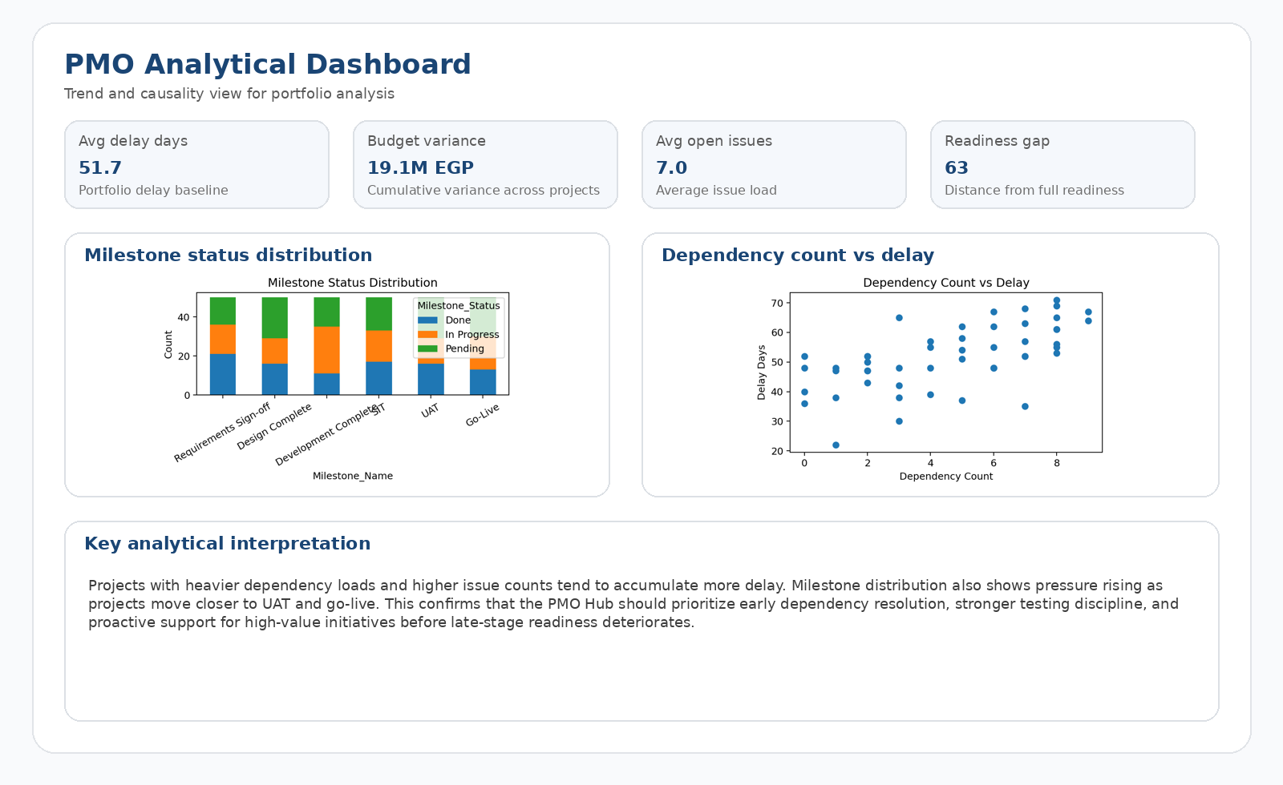
Figure 2. Analytical dashboard showing trend and causality views from the PMO dataset.

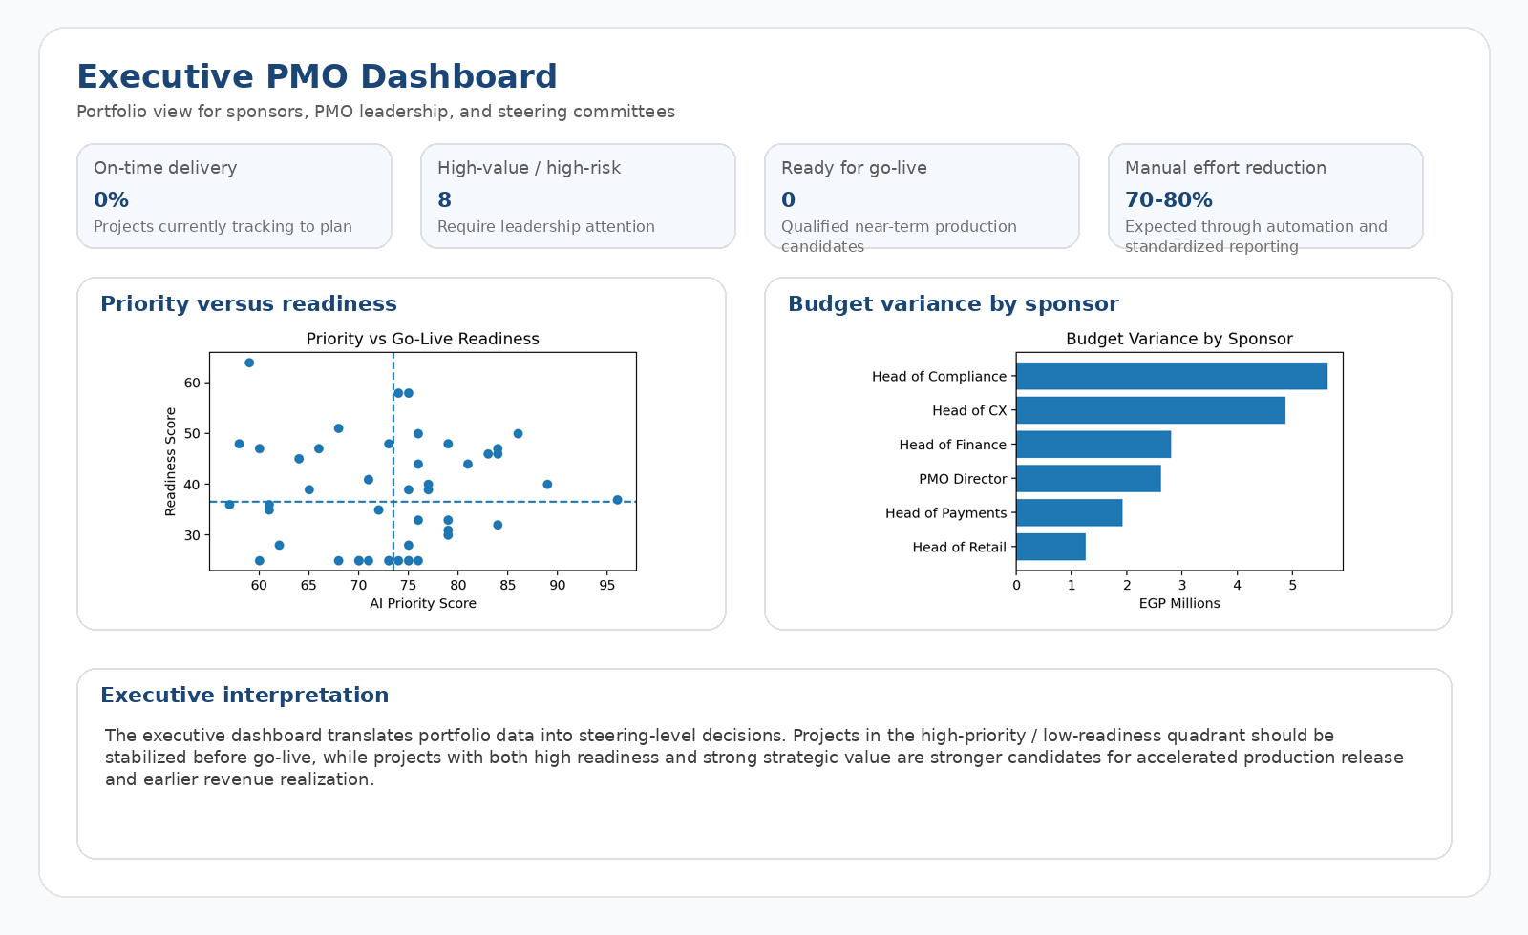
Figure 3. Executive dashboard for sponsorship and steering decisions.
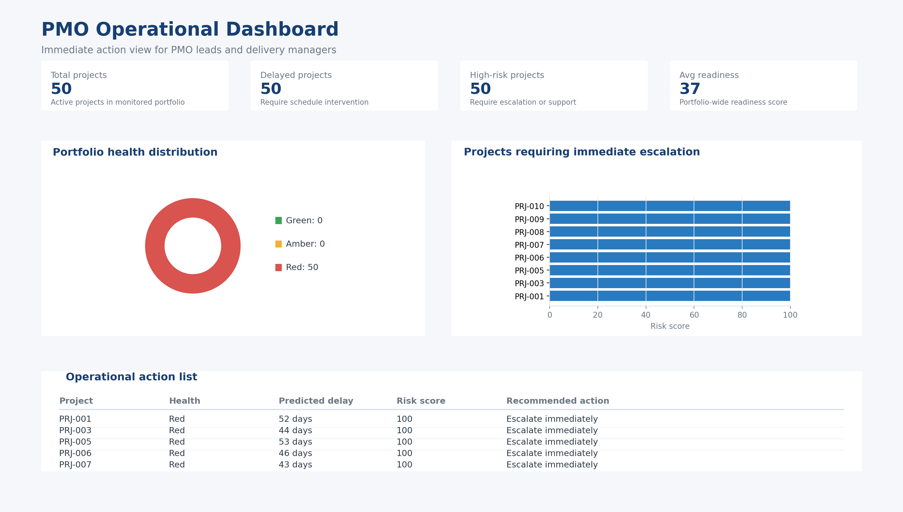
Figure 4. Conceptual PMO operational dashboard highlighting escalation needs, risk concentration, and immediate actions.
The solution includes three dashboard families. The operational dashboard focuses on immediate action, such as delayed projects, blocked milestones, critical issues, and high-risk projects. The analytical dashboard focuses on trends and relationships, such as actual versus predicted delay, risk concentration by project type, budget variance by sponsor, and readiness distribution by function. The executive dashboard focuses on strategic priorities, including total project load, on-time delivery, high-risk projects, revenue-linked initiatives nearing go-live, and AI-prioritized action lists.
Representative chart types include portfolio-health distributions, delay trend lines, readiness score bar charts, budget variance comparisons, and heat maps of issue concentration. Conceptual analytical models include classification models for delay prediction, clustering models for portfolio segmentation, and scoring models for prioritization and readiness.
5.7 Explain the Decision-Making Using Data Mining Techniques
Decision-making in the PMO Hub is supported by classification, clustering, correlation analysis, and anomaly detection. Classification determines whether a project is likely to be delayed or not ready. Clustering groups projects with similar governance characteristics. Correlation analysis reveals which variables move together, such as high dependencies and high delay. Anomaly detection highlights unusual project behavior that should not wait until the next reporting cycle.
These techniques support decisions about escalation, resource allocation, sequencing, sponsor intervention, and go/no-go readiness. In that sense, data mining is not an academic add-on; it is the engine behind more consistent governance action.
5.8 Results of Data Analysis
The synthetic dataset produced several meaningful findings. First, projects with higher dependency counts consistently showed longer delay days. This supports the argument that dependency management is one of the strongest drivers of portfolio instability. Second, projects with larger change-request volumes and higher defect counts tended to have lower readiness scores. This shows that scope instability and quality instability jointly reduce deployment confidence.
Third, projects with high compliance impact tended to show higher overall risk scores and required more governance attention, which is realistic in a fintech environment. Fourth, projects with lower resource utilization levels often displayed higher schedule variance, confirming that governance requires finance and planning data in addition to delivery data. Finally, higher UAT-completion percentages were strongly associated with better readiness outcomes, reinforcing the importance of testing maturity in production decisions.
6. Digital Transformation Analysis
The proposed PMO Hub contributes to digital transformation by changing how governance work is performed, how decisions are made, and how data is used inside the organization. The current-state PMO is primarily manual and descriptive. The future-state PMO becomes integrated, automated, predictive, and more closely aligned with business value creation.
6.1 Changes in Business Processes and Workflows
The PMO process changes from manual collection and retrospective reporting to continuous monitoring and earlier intervention. Project data moves from isolated trackers into an integrated layer, and governance reviews become informed by scores, thresholds, and trend signals rather than only narrative updates.
6.2 Automation of Manual or Repetitive Tasks
RPA automates recurring reporting tasks, reminders, escalation triggers, and governance-pack preparation. This frees PMO capacity and reduces the delay between data change and management response.
6.3 Impact on Organizational Culture and Decision-Making
The PMO Hub encourages a more data-driven governance culture. Decision-making becomes less dependent on the loudest project voice and more dependent on structured evidence. Transparency increases because portfolio conditions become easier to compare and explain.
6.4 Customer Experience Improvements
Although the PMO Hub is an internal solution, it indirectly improves customer experience. Earlier launch readiness, fewer avoidable rollout disruptions, and better execution discipline mean that end customers and partners receive more reliable services and faster access to new capabilities.
6.5 Comparison of Before vs. After Digital Transformation
Dimension | Before | After
Reporting | Manual, spreadsheet-based | Automated, dashboard-driven
Risk management | Reactive | Predictive
Readiness review | Late-stage and fragmented | Early and continuous
Prioritization | Subjective and pressure-driven | Data-backed and explainable
Decision speed | Slower, meeting-dependent | Faster, insight-led

7. ERP Integration & Role (Mandatory)
7.1 ERP Modules Involved
The PMO Hub is designed to interact conceptually with several ERP-related modules. Finance modules provide planned and actual cost visibility. Resource-planning or HR-related modules provide allocation and capacity data. Procurement or vendor-related records can support external-dependency visibility. Reporting layers provide standardized outputs for management views.
These modules matter because PMO governance should not look only at project status. It should also understand budget movement, capacity pressure, vendor dependence, and the timing implications of these factors.
7.2 How AI Integrates with ERP Systems
The AI layer does not replace ERP. Instead, it sits above core enterprise systems as an intelligence layer. It consumes relevant ERP and workflow data, enriches that data with project-delivery context, applies scoring and predictive logic, and returns insights through dashboards and governance workflows.
7.3 Data Flow Between AI Tools and ERP
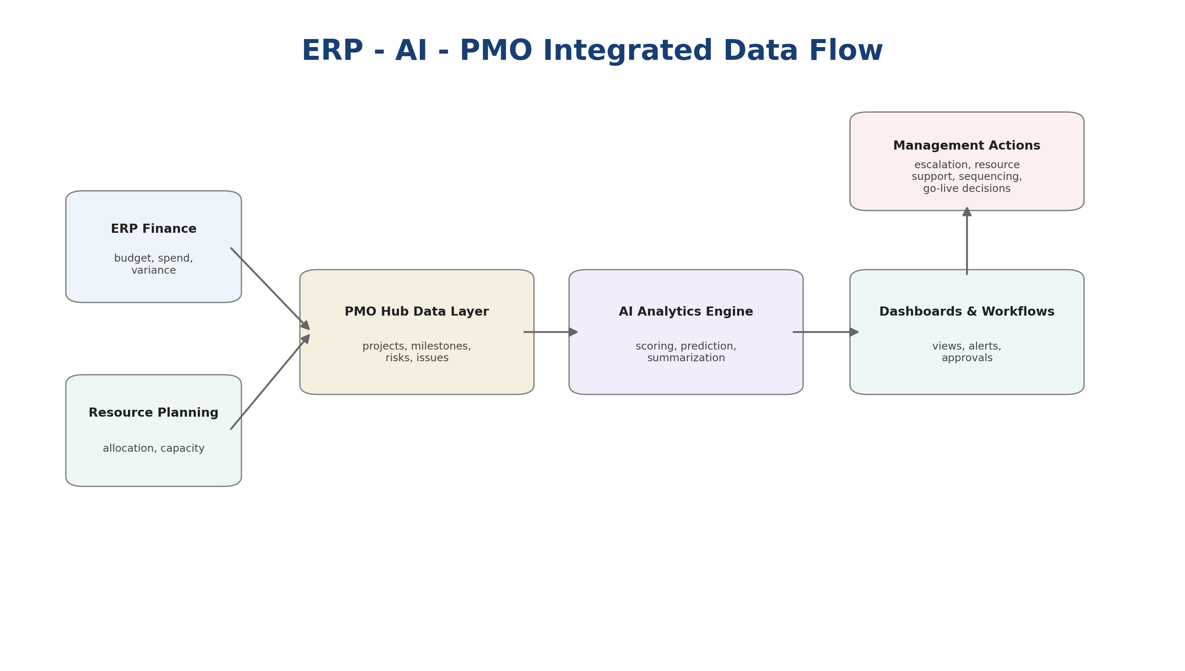
Figure 5. ERP–AI–PMO integrated data flow showing how enterprise records feed the hub and support management decisions.
In the proposed flow, ERP finance and resource records, PMO trackers, issue logs, milestone updates, and workflow data feed a centralized data layer. That data layer supplies the analytics engine. The AI engine then generates readiness scores, delay forecasts, risk patterns, summary insights, and action recommendations. These outputs appear in dashboards and can also trigger automated workflow actions.
Flow Stage | Role in the architecture
ERP / PMO / workflow inputs | Provide financial, operational, resource, and status data
Integrated data layer | Consolidates and standardizes inputs
Analytics & AI engine | Generates predictions, scores, and summaries
Dashboards & workflows | Support action, escalation, and management decisions

7.4 Benefits of ERP + AI Integration
The integration creates better budget visibility, stronger resource planning, faster sponsor reporting, improved readiness transparency, and more consistent governance logic across projects. Most importantly, it connects execution signals with business-control signals, which is necessary for effective PMO decision support.
7.5 Challenges in ERP Implementation or Customization
Typical challenges include legacy system limitations, inconsistent data definitions, missing fields, integration effort, dashboard customization complexity, and adoption risks. These challenges do not invalidate the model, but they mean that implementation should begin with a controlled pilot rather than a big-bang rollout.
7.6 Draw Flow Chart, BPM and Workflows
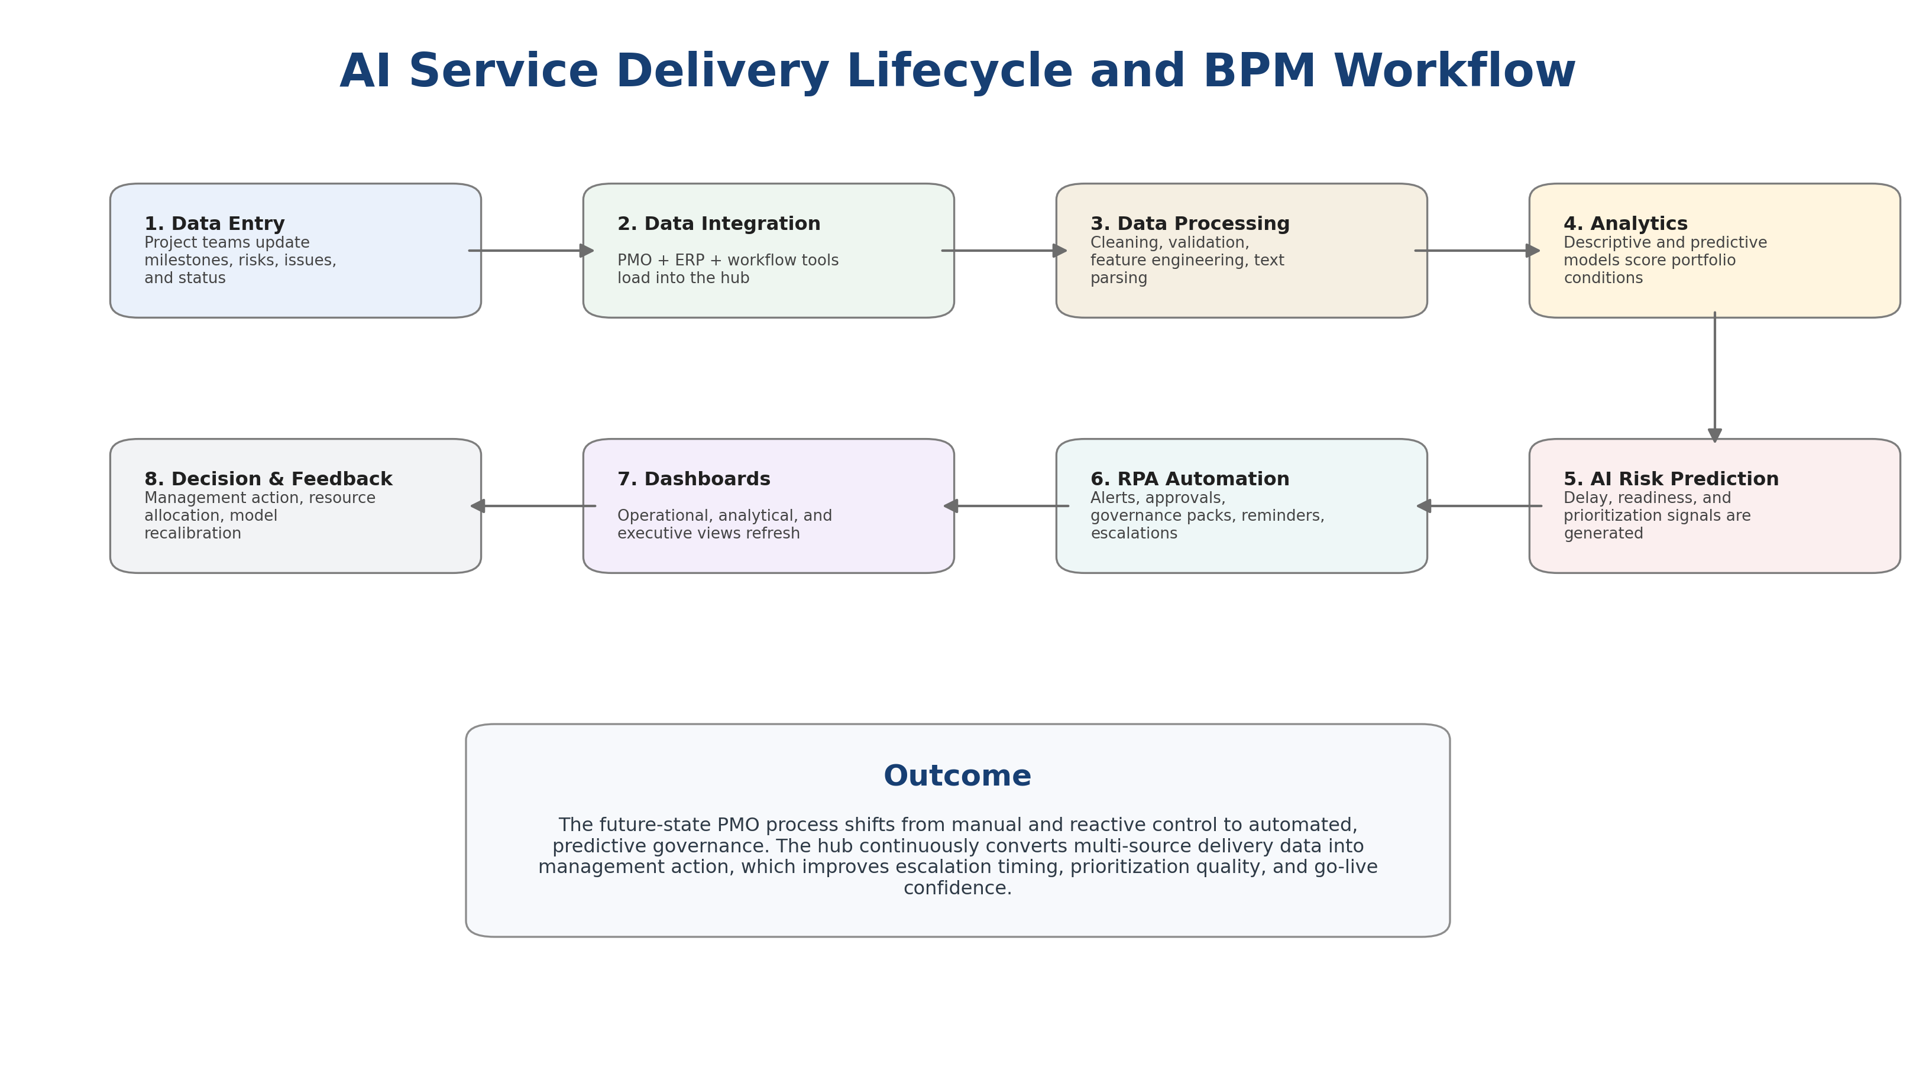
Figure 6. AI service delivery lifecycle and BPM workflow for the PMO Hub.
The report includes a conceptual BPM model in which project and enterprise systems feed the PMO Hub; the hub applies analytics, AI scoring, and workflow automation; and dashboards then support governance decisions and create a feedback loop into project execution. This BPM shift is important because it changes governance from reactive collection to proactive intervention.
8. Business Impact & Value Creation
8.1 Financial Impact (Cost Reduction, Revenue Growth, ROI)
The most direct financial effect of the PMO Hub is reduced inefficiency in governance and execution. When the PMO identifies delay risks earlier, the organization can intervene before the project slips further. This reduces avoidable rework, protects budget discipline, and improves the timing of value realization. In fintech portfolios that include revenue-generating initiatives, earlier readiness and earlier production activation can also accelerate revenue generation.
Indicative impact assumptions used in this case include a 10–15% reduction in avoidable delays, a 70–80% reduction in recurring manual PMO consolidation effort, and earlier activation of qualified projects that have commercial value. These assumptions are not presented as guaranteed results but as realistic business-case estimates grounded in the operating logic of the solution.
8.2 Operational Efficiency Improvements
Operationally, the PMO Hub increases visibility, reduces manual effort, speeds up escalation, and supports more reliable readiness control. PMO staff can spend less time preparing reports and more time analysing exceptions, resolving constraints, and supporting governance decisions.
8.3 Strategic Advantages Gained
Strategically, the solution improves portfolio prioritization, strengthens executive confidence in delivery information, and aligns PMO activity more closely with business value and risk exposure. It also helps position the PMO as a strategic enabler rather than a back-office reporting function.
8.4 Scalability and Long-Term Sustainability
The model is scalable because the same logic can be applied across portfolios with different project types. It is sustainable because it relies on reusable data structures, repeatable workflows, and governed dashboards rather than on individual manual effort.
Business Area | Expected Improvement
Avoidable project delays | 10–15% reduction
Manual PMO reporting effort | 70–80% reduction
Executive visibility speed | Near real-time rather than weekly manual reporting
Readiness control | Earlier identification of non-ready projects
Revenue realization timing | Earlier activation of qualified production projects

9. Risks, Ethical Issues & Limitations
9.1 Data Privacy and Security Concerns (GDPR)
Any PMO Hub that consolidates project, financial, and resource data must apply strong privacy and security controls. Although the case does not process customer personal data as its primary objective, the organization must still enforce role-based access, data minimization where relevant, controlled retention, and secure reporting practices. Where project comments or operational notes contain personal or sensitive details, privacy-by-design principles should apply.
9.2 Bias in AI Models
AI models may reproduce historical bias if past prioritization or escalation patterns were inconsistent or politically influenced. For example, projects sponsored by visible departments may historically have received more attention than equally risky projects in less visible areas. Human review and explainability are therefore necessary.
9.3 Regulatory or Compliance Issues
In fintech, governance tools that influence prioritization, readiness, or resource decisions should remain auditable and explainable. Management must be able to justify why a project was escalated, delayed, or prioritized. The model should therefore support internal audit expectations and wider AI-governance principles.
9.4 Technology Adoption Risks
Users may resist AI-driven recommendations if they do not understand the logic or if they believe the tool conflicts with existing governance practice. Adoption risks include lack of trust, change fatigue, and overreliance on automation without sufficient managerial judgment.
9.5 Limitations of AI and ERP Systems
AI predictions depend on data quality, completeness, and consistency. ERP systems may not contain all fields needed for advanced PMO analysis, and customization can be costly. The case also uses synthetic data, so the findings are illustrative rather than a substitute for live enterprise validation.
9.6 Select ISO 27001 Clause Related to Your Topic
For this topic, the most relevant ISO/IEC 27001 control themes are access control, logging and monitoring, information classification, and supplier-related controls. Access control is critical because the PMO Hub contains sensitive schedule, cost, and governance data. Logging and monitoring are required to audit who viewed or changed important records. Information classification is necessary because not all project data carries the same sensitivity. Supplier-related controls matter where external vendors or platforms participate in workflows or integrations.
These controls strengthen the case by showing that the PMO Hub is not only analytically useful but also aligned with enterprise security governance.
10. Recommendations & Future Scope
10.1 Strategic Recommendations for Improvement
The recommended implementation approach is to start with a pilot portfolio, standardize PMO data definitions, clarify ownership over AI-generated insights, and maintain a human-in-the-loop governance model. Early wins should focus on readiness visibility, risk escalation, and reporting automation before expanding into more advanced optimization use cases.
10.2 Suggestions for Advanced Analytics or AI Upgrades
Future upgrades may include richer NLP over project narratives, anomaly-detection models for milestone behaviour, stronger calibration of predictive accuracy, and conversational AI assistants that answer portfolio questions in natural language.
10.3 Future Digital Transformation Opportunities
The PMO Hub can evolve into a broader portfolio control tower connected to collaboration tools, risk systems, and executive decision boards. It may also support scenario analysis for sequencing large programs or balancing resource allocation across strategic initiatives.
10.4 Expansion of ERP–AI Capabilities
Further ERP–AI integration could support budget forecasting, capacity optimization, vendor performance intelligence, and scenario planning. Over time, the organization could move from a governance-support model to a broader enterprise planning-support model.
11. Conclusion
This report has shown that an AI-enabled PMO Hub is a strong fit for fintech organizations that need faster, more integrated, and more predictive governance. By connecting AI, analytics, automation, and ERP-linked data, the PMO can shift from manual reporting to intelligence-led control without losing explainability or governance discipline.
The case also shows that the value of AI in PMO is not limited to technical prediction. Its real value lies in improving the timing and quality of managerial action. Better prioritization, earlier escalation, stronger readiness control, and faster executive visibility all contribute to operational improvement and earlier business value realization. For fintech organizations, these gains are strategically significant because speed, reliability, and execution discipline directly influence competitiveness.

12. References
Aguirre, S., & Rodriguez, A. (2017). Automation of a business process using robotic process automation (RPA): A case study. In Lecture Notes in Computer Science (Vol. 10652, pp. 65–71). Springer.
Davenport, T. H., & Ronanki, R. (2018). Artificial intelligence for the real world. Harvard Business Review, 96(1), 108–116.
European Commission. (2021). Proposal for a regulation laying down harmonised rules on artificial intelligence (Artificial Intelligence Act).
Floridi, L., & Cowls, J. (2021). A unified framework of five principles for AI in society. Harvard Data Science Review, 3(1).
International Organization for Standardization. (2022). ISO/IEC 27001:2022 Information security, cybersecurity and privacy protection—Information security management systems—Requirements.
Kaplan, A., & Haenlein, M. (2019). Siri, Siri, in my hand: Who’s the fairest in the land? On the interpretations, illustrations, and implications of artificial intelligence. Business Horizons, 62(1), 15–25.
Marr, B. (2021). Artificial intelligence in practice (2nd ed.). Wiley.
Nerella, A., & Sajja, J. W. (2023). Responsible AI in enterprise applications: Balancing innovation and compliance. Computer Fraud & Security, 2023(7), 43–52.
Project Management Institute. (2021). A guide to the project management body of knowledge (PMBOK® guide) (7th ed.).
Raji, I. D., Smart, A., White, R. N., Mitchell, M., Gebru, T., Hutchinson, B., Smith-Loud, J., Theron, D., & Barnes, P. (2020). Closing the AI accountability gap: Defining an end-to-end framework for internal algorithmic auditing. In Proceedings of the 2020 Conference on Fairness, Accountability, and Transparency (pp. 33–44).
Shneiderman, B. (2020). Human-centered artificial intelligence: Reliable, safe, and trustworthy. International Journal of Human–Computer Interaction, 36(6), 495–504.
van der Aalst, W. (2016). Process mining: Data science in action (2nd ed.). Springer.
Westerman, G., Bonnet, D., & McAfee, A. (2014). Leading digital: Turning technology into business transformation. Harvard Business Review Press.
Wirth, R., & Hipp, J. (2000). CRISP-DM: Towards a standard process model for data mining. In Proceedings of the 4th International Conference on the Practical Applications of Knowledge Discovery and Data Mining (pp. 29–39).
13. Appendices
Appendix A. Note on Simulated Data and AI Support
This report uses simulated portfolio data because real fintech project data is confidential. The synthetic dataset was designed to mimic realistic PMO patterns while protecting commercial and operational sensitivity.
AI tools were used as a support mechanism for structuring, drafting, and analytical assistance. Final analysis, judgment, interpretation, and report organization were adapted to reflect the student’s understanding and the project requirements.

